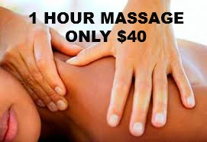

MEET OUR
NEW MASSAGE THERAPISTS!
20% OFF ALL MASSAGE TREATMENTS
1 HOUR ONLY $40 ($10 OFF)
½ HOUR ONLY $23
Good from April 15 – May 15, 2014. Limit 2 per customer.

